Activity 2
Constituency Parse Trees
Constituency parsing breaks down a sentence into nested sub-phrases (constituents), each belonging to a specific grammatical category (like Noun Phrase or Verb Phrase). These trees are crucial in Natural Language Processing (NLP), a key component of intelligent systems.

Here are the parse trees for your three sentences:
1. The government raised interest rates.
This sentence has a straightforward structure: a subject (NP) performs an action (V) on an object (NP).

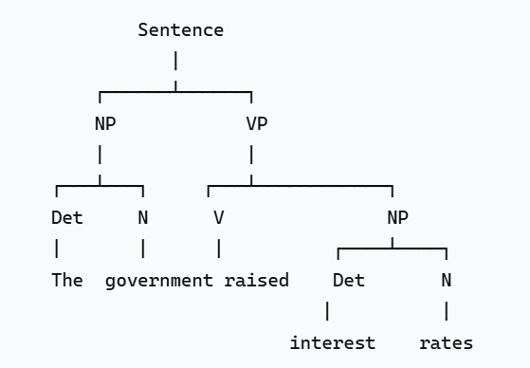
Figure 1: The government raised interest rates

2. The internet gives everyone a voice.
This sentence contains a ditransitive verb ("gives"), which means it has two objects: an indirect object ("everyone") and a direct object ("a voice").
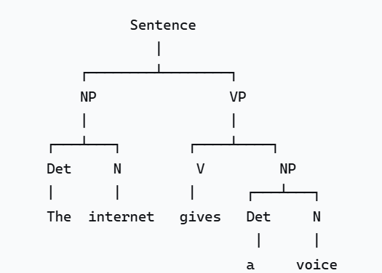
Figure 2: The internet gives everyone a voice.

3. The man saw the dog with the telescope.
This sentence is structurally ambiguous. The Prepositional Phrase (PP) "with the telescope" can modify either the verb "saw" (meaning the telescope was the instrument used for seeing) or the noun "dog" (meaning the dog had the telescope). This ambiguity is a classic challenge in NLP. An intelligent system must disambiguate this to understand the true meaning.
Interpretation A: The man used the telescope to see the dog.
(The PP "with the telescope" modifies the verb "saw")
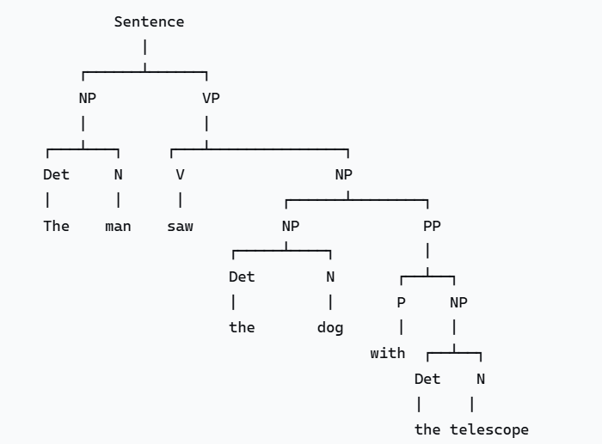

Interpretation B: The man saw the dog that had the telescope.
(The PP "with the telescope" modifies the noun "dog")
